# **Tomcat: Application Server**

**Pre-Requisites:**

* Tomcat installed
* JDK installed

**References:**

* [www.baeldung.com/tomcat-deploy-war](http://www.baeldung.com/tomcat-deploy-war)
* [www.digitalocean.com](http://www.digitalocean.com)

## 

## 

## 

## 

## 

## 

## 

## 

## 

## Q1) DEPLOY A WAR FILE IN TOMCAT

## **Step 1:** Type command → sudo systemctl enable tomcat

to start tomcat .

**Step 2:** Type command → $ sudo vi /opt/tomcat/conf/tomcat-users.xml

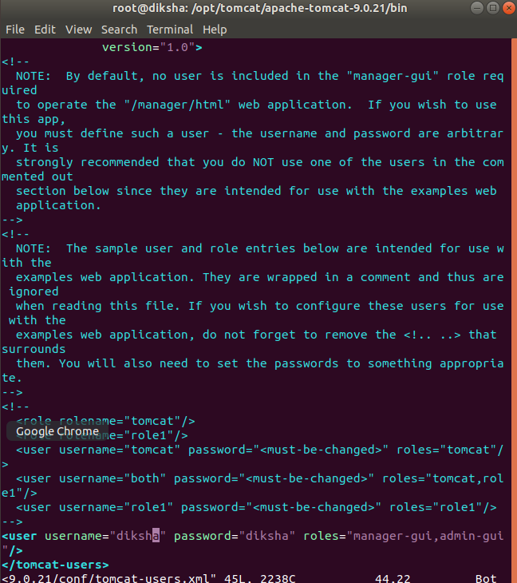

**Step 3:**.Enter your server's domain name or IP address followed on port 8080 in your browser:

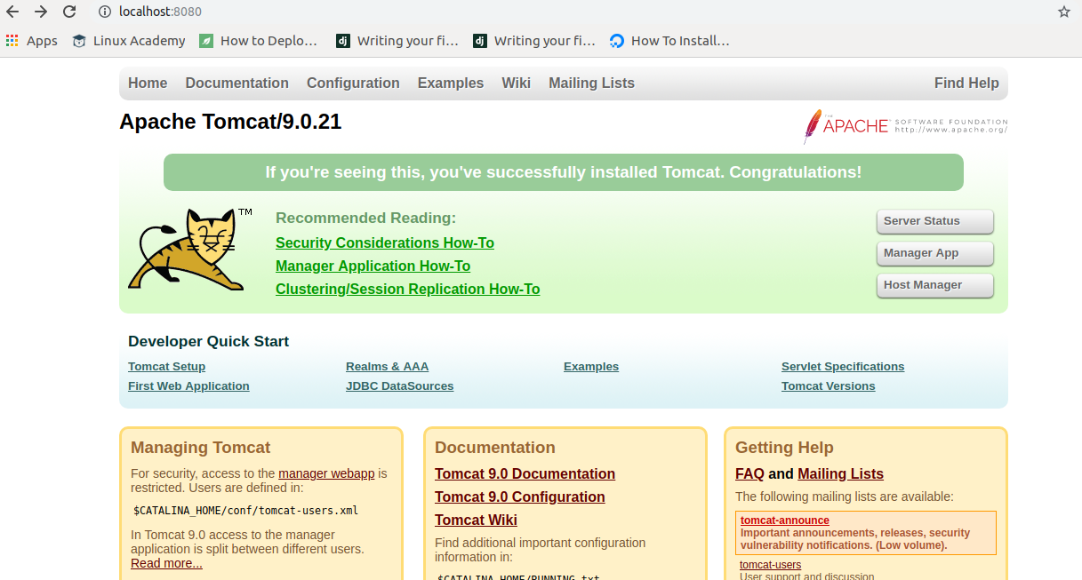

**Step 4:** Let's take a look at the Manager App, accessible via the link or <[http://server_domain_or_IP:8080/manager/html](http://server_domain_or_ip:8080/manager/html)> . You will need to enter the account credentials that you added to the tomcat-users.xml file

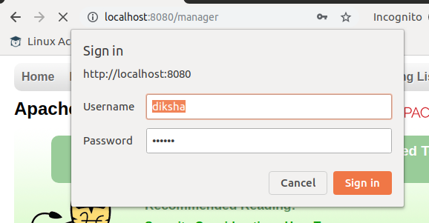

**Step 5:** Afterwards, you will see a page that looks like this:

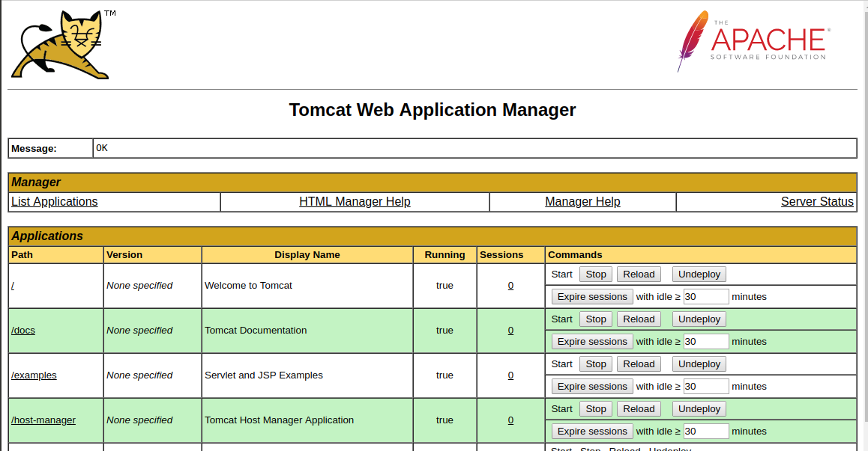

**Step 6:** Download any war file.

**Step 7:** Copy the WAR file to <CATALINA_HOME/webapps >.

**Step 8:** Start the Tomcat server

**Step 9:** Fill the entries as given below:

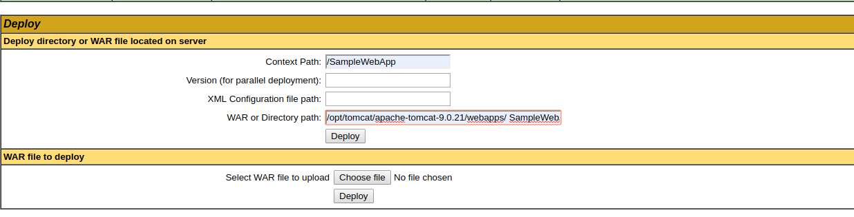

**Step 10:** You war file has been deployed.

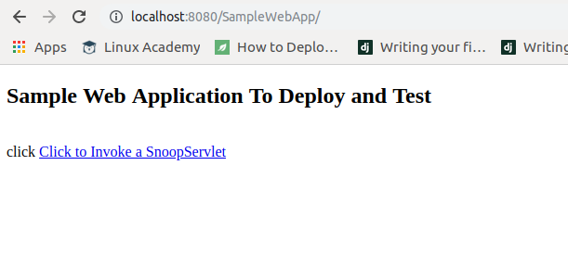

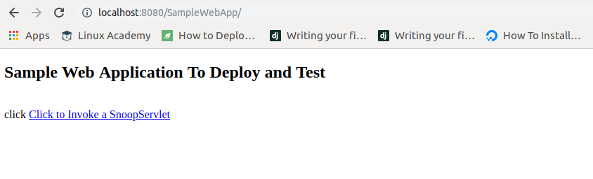

## 

## Q2)Two tomcats running on same server with different port.

**Step 1**:Open server.xml file and one more connector with different port number and save the file.

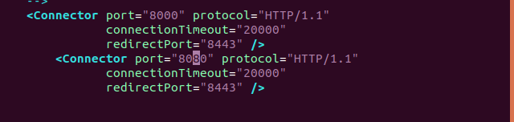

**Step 2**: Shutdown the server and again start the server by running command ./startup.sh.

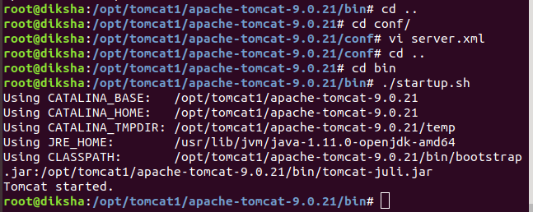

**Step 3**: Run localhost 8080 and localhost 8000.You will observe tomcat home page .

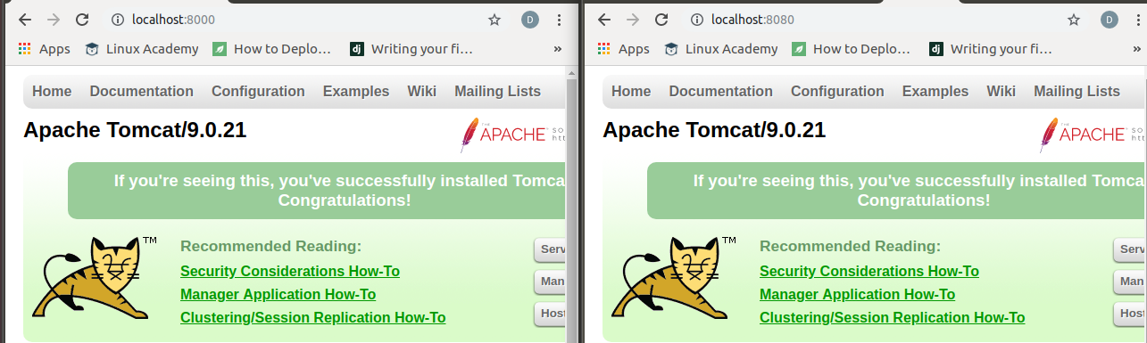

## Q 3)What is the use of digest.sh? Where can its encryption be used?

## **Ans:** digest.sh is script to encryt the password.

Its encryption can be used to encrypt password for the manager and admin-gui in tomcat.

**Step 1:** Add credential handler to handle the encrypted password.

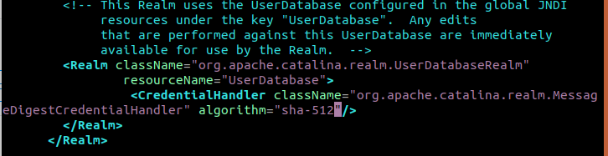

**Step 2:** Use digest.sh to encrypt your password.



**Step 3:** Copy the generated password into tomcat  
-user.xml file and save the changes.

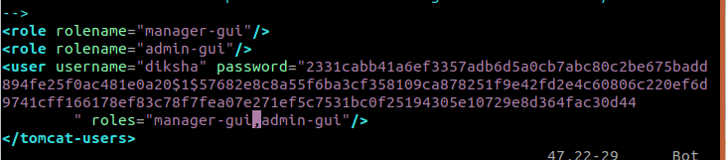

**Step 4:**

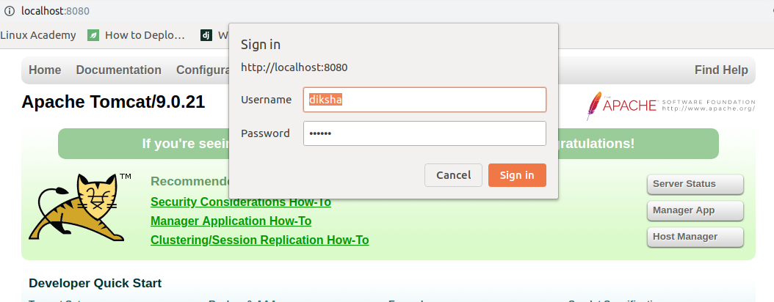

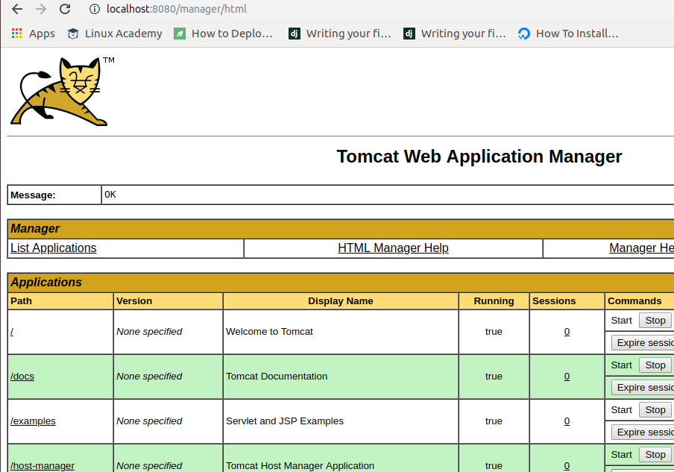

## Q 4)Apply SSL tomcat (8443 in server.xml).

**Step 1:**“keytool” command to create a self-signed certificate. During the keystore creation process, you need to assign a password and fill in the certificate’s detail.

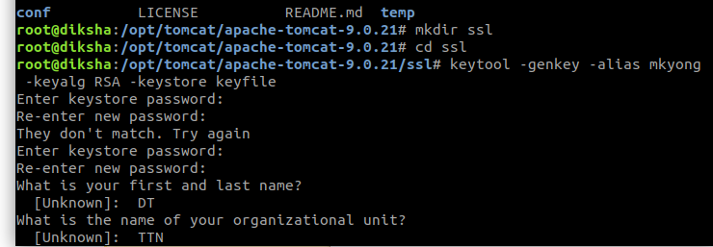

**Step 2:** Here, you just created a certificate named “keyfile“, which ssl directory in tomcat

**Step 3:** Modify server.xml by adding a connector element to support for SSL or https connection.

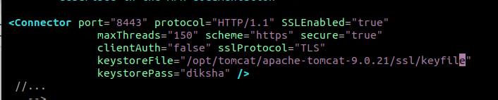

**Step 4**: Shutdown and again start the server. Run localhost at port 8443.

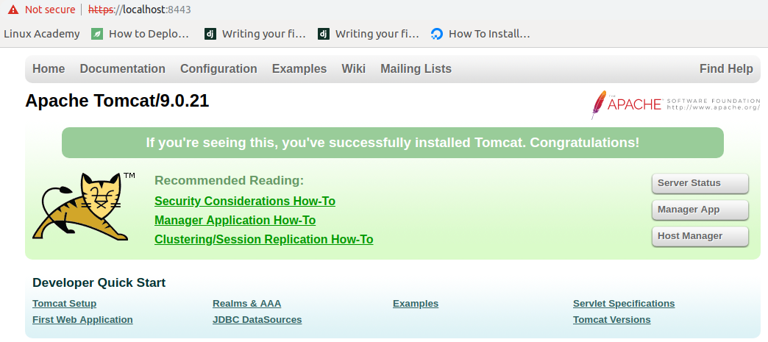

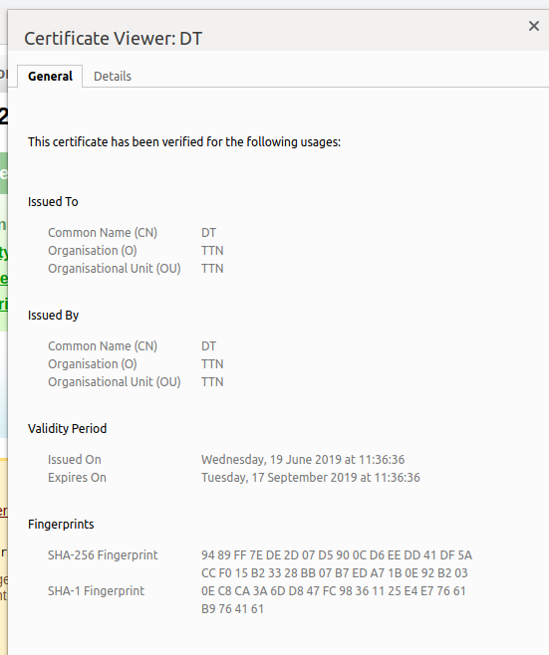

## Q 5)Logging --> client ip,request, date, connector.

Before:

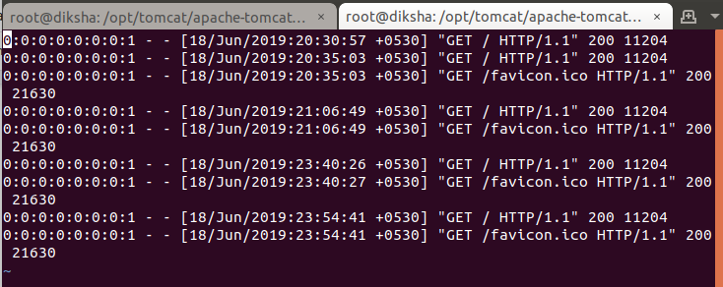

Make the desired changes in the logs file:

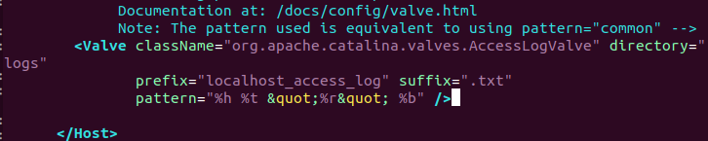

After:

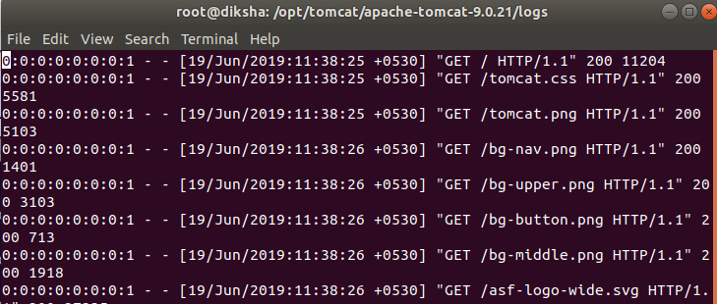

## Q 6)JDBC define server.xml

## Q 7)Connect nginx → tomcat → db

